

Lab Week 2
The Internet Protocols
Shahad Nasser Alwatban

Part 1: Capturing HTTP Traffic.
Task 1: Start Wireshark and capture packets.
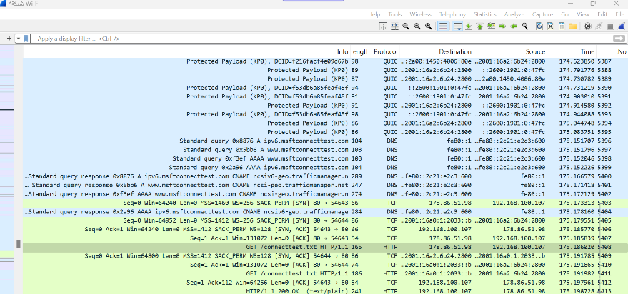
"I opened Wireshark and Selected the network interface connected to the internet (Wi Fi) and them I Capturing Packets and then Open web browser and navigate to (https://qu.edu.sa) website after the website has fully loaded, stop capturing packets "

Task 2: Filter HTTP packets and analyze them.
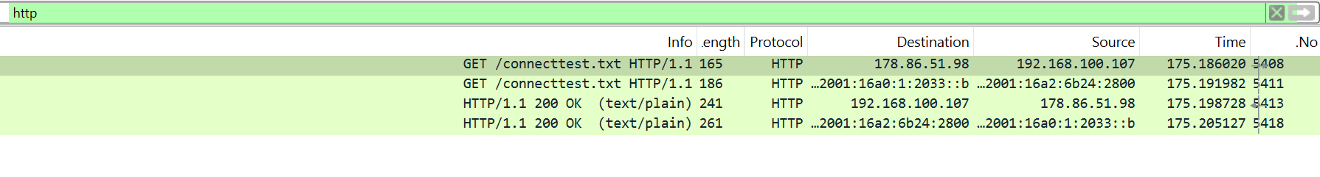
In filter bar, I filter only HTTP packets from the capture, and I found HTTP request messages (GET) also another one with response codes (200 OK):
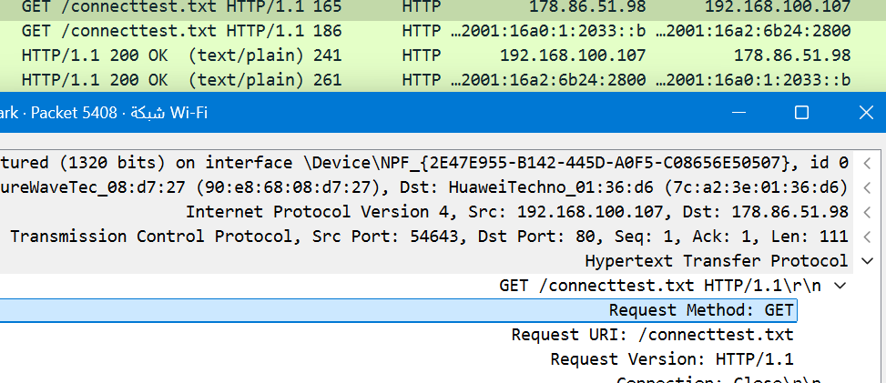
Here is HTTP request with GET method.

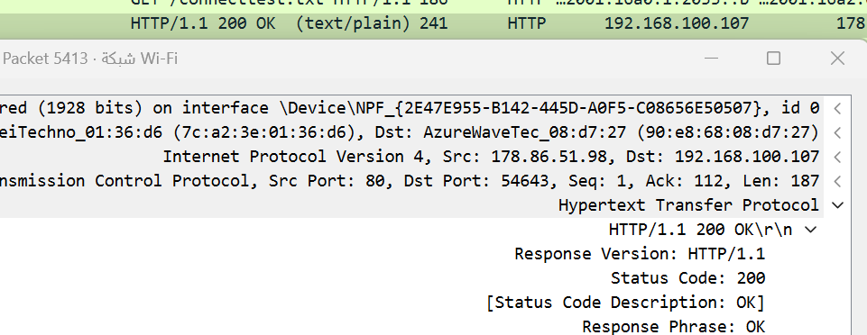
Here is HTTP response with response 200 ok.

Part 2: Analyzing TCP/IP Traffic.
Task 1: Filter TCP packets
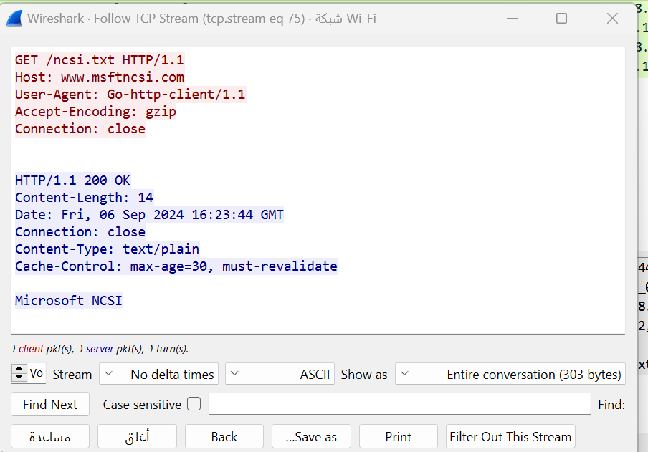
Here I Select a TCP packet related to HTTP and select "Follow" -> "TCP Stream", This shows the entire conversation between the client and server.

Task 2: Analyze TCP handshake and investigate Data Transfer and Termination
I Find packets related to the TCP three-way handshake (SYN: Initiates a connection, SYN-ACK: Acknowledges and responds to the SYN, ACK: Acknowledges the SYN-ACK and establishes the connection.)
Here sequence and acknowledgment numbers.

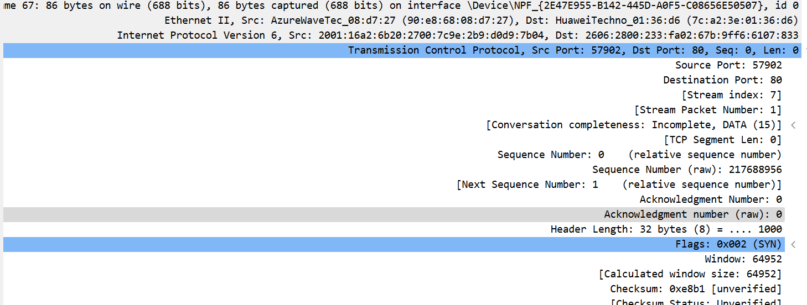
SYN : the sequence and acknowledgment numbers

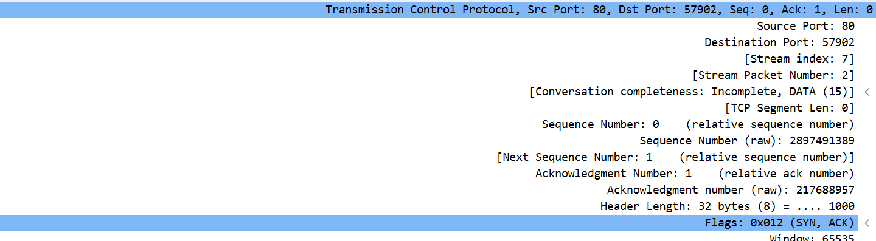
SYN-ACK: the sequence and acknowledgment numbers

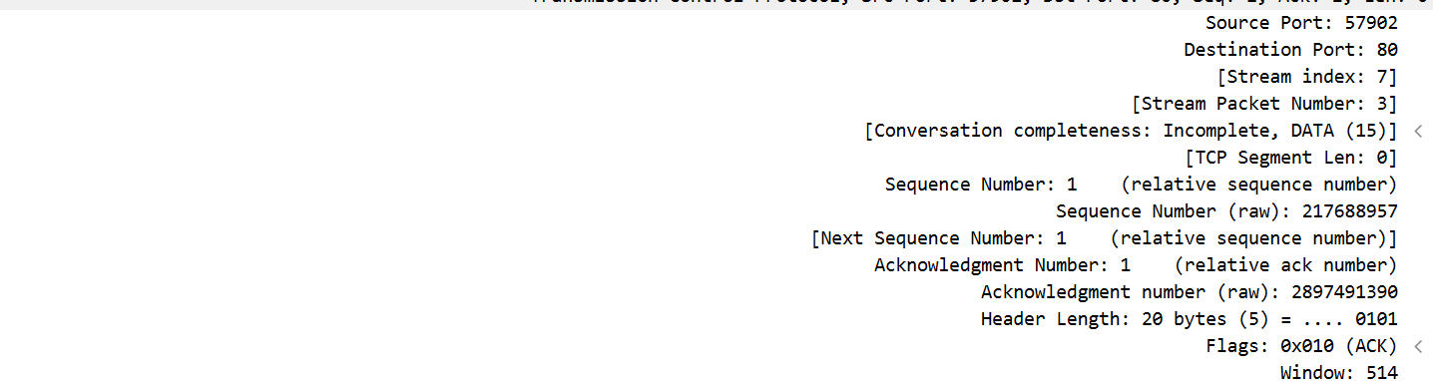
ACK: the sequence and acknowledgment numbers

I use the "Follow TCP Stream" option to view the entire conversation between the client and server. This feature will show the data exchanged in a more readable format.
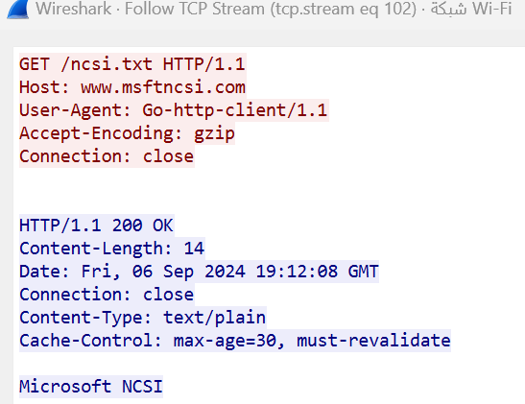

I looked at the TCP termination process (FIN, ACK packets) by using " tcp.flags.fin == 1" in the filter.
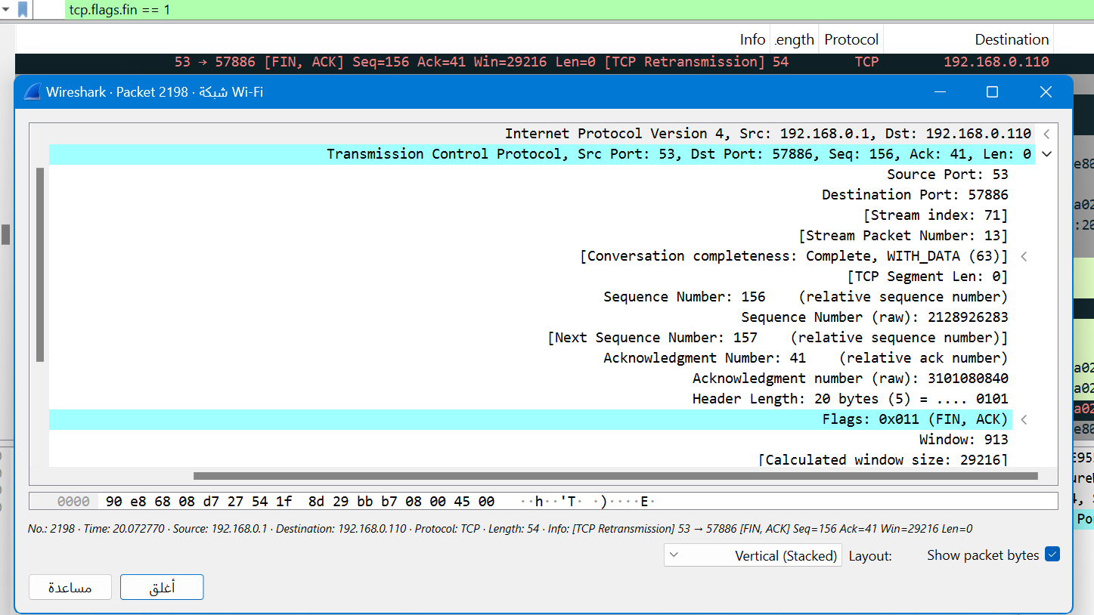

Part 3: Capturing and Analyzing UDP Traffic
Task 1: Generate UDP traffic and capture packets
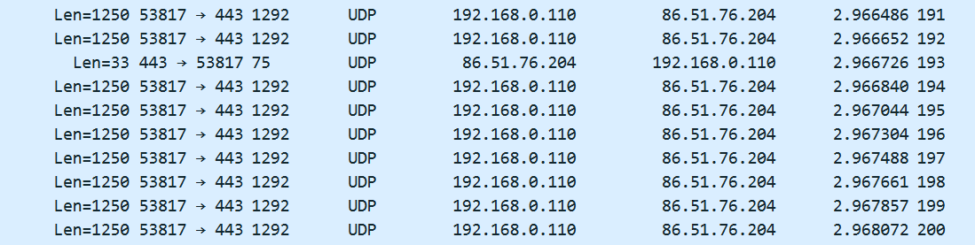
In the filter bar, I type UDP

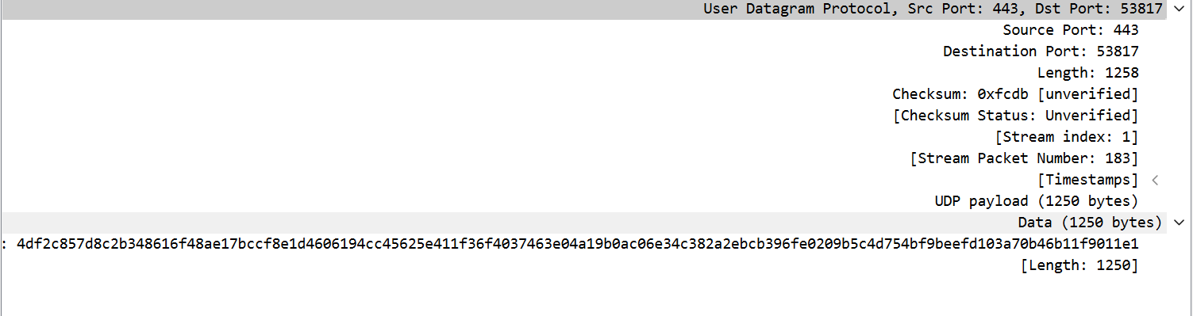
Observe the source and destination ports, length, and data.

Compare the simplicity of UDP headers with TCP headers:
The UDP header is much simpler, consisting of only 4 fields while TCP header is significantly more complex because TCP offers features like connection establishment, reliability, flow control, and congestion control. The TCP header consists of 10 mandatory fields

Part 4: Comparing TCP and UDP by filling in the following tables. Save your work (e.g., in an MS Word document), and upload it to your online git repo.
Task 1: Fill in the following table and provide reasons.
 | TCP or UDP | Reasons
Reliability and Connection Establishment | TCP | TCP uses acknowledgments (ACKs), Error Detection and Correction and Sequencing, unlike UDP
Data Integrity and Ordering | TCP | Each TCP segment includes a checksum for error detection, Guaranteed Ordering, Acknowledgments and Retransmissions, Error Detection and Correction unlike UDP

Task 2: Identify the use Cases and Performance of TCP and UDP.
 | TCP | UDP
Use case | - Web browsing  - Email  - File Transfer | - Live video  - Online gamming  - Audio streaming
Performance | Reliability, Throughput, Latency, Overhead, Connection-Oriented Nature, Data Ordering and Performance Optimization Techniques | Optional checksum enables error detection, while minimal overhead, lack of connection setup, and small headers ensure high throughput, low latency, and reduced overhead.

